**JAIPUR ENGINEERING COLLEGE AND RESEARCH CENTRE**

**DEPARTMENT OF ENGLISH AND HUMANITIES**

**A REPORT (ESSAY WRITING COMPETITION)**

**ON**

**THE CELEBRATION OF 150TH BIRTH ANNIVERSARY**

**OF MAHATMA GANDHI**

The 150th birth anniversary of Mahatma Gandhi – The Father of Nation was celebrated in the college with full zeal and fervor on 2nd October, 2018. On this occasion, the Department of English and Humanities organized an Essay Writing Competition for spreading the ever inspiring views of Mahatma Gandhi among the new and younger generations of the college. That today’s youth is already much aware of and impressed with the Gandhian views, was once again proved by the huge number of participation and the content they shared in their essays.

As Gandhiji was a staunch supporter of the basic education in the country which, he believed, should not be restricted in the boundaries of any mediums of instructions, languages, class or category. Keeping this view in mind, the department offered two burning topics in both the languages – English and Hindi.

The topic in English was – Be The Change: A Gandhian View

The topic in Hindi was – *De Dee Hamein Aazadi Bina Khadag Bina Dhaal*

The department received an overwhelming response for essay writing and the total number of the participants was 181. The participants expressed their views precisely in the essays.

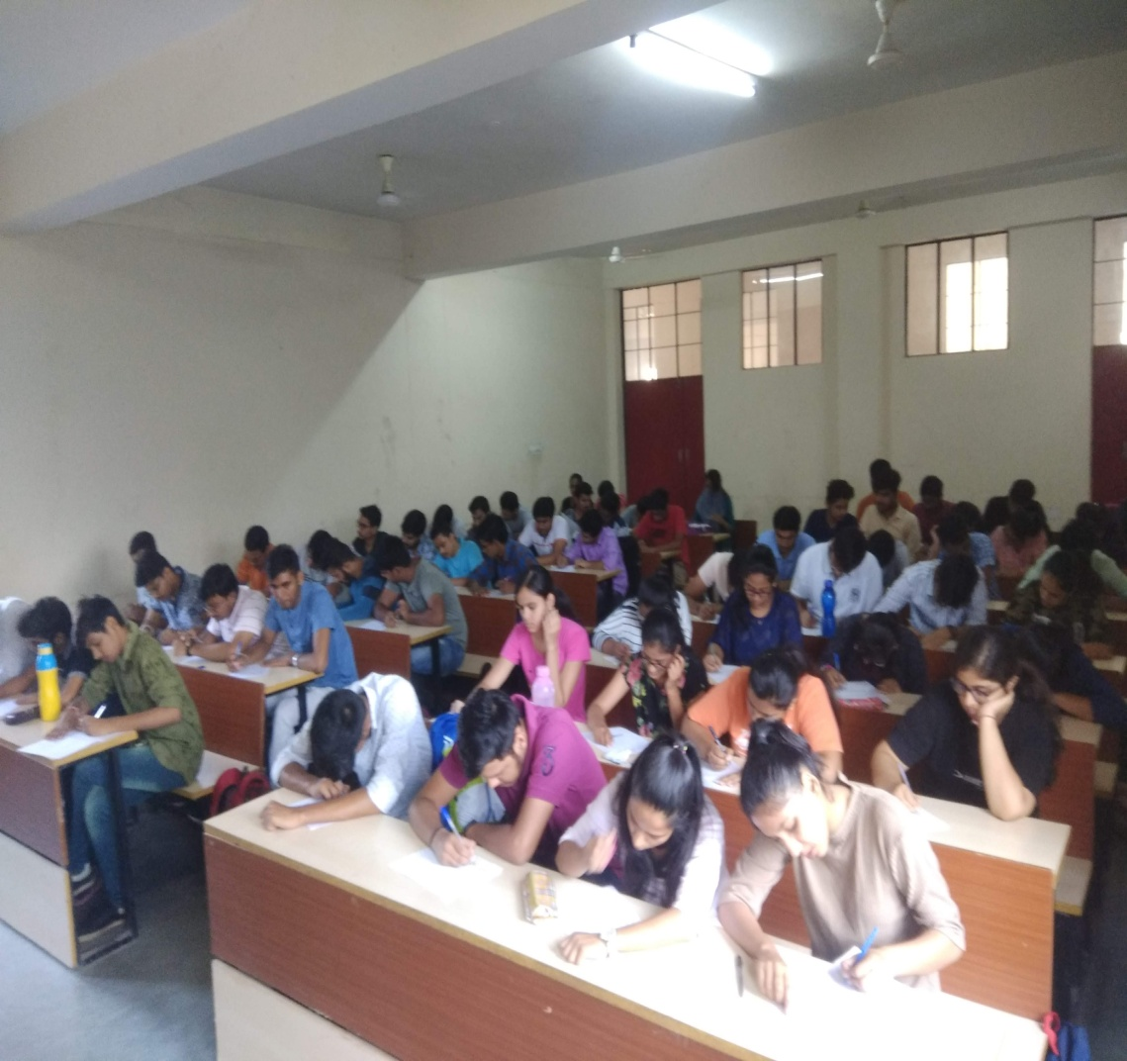

After going through the views of the students in the essays, the result declared was as follows-

In English – 1st – Ms. Sakshi Natani, ECE 1st Year

2nd – Ms. Khushboo Jethwani, ECE 1st Year

3rd – Ms. Prachi Sinha, ECE 1st Year

In Hindi – 1st – Mr. Ambar Shukla, ME 1st Year

2nd – Ms. Shalu Jangid, CSE 1st Year

3rd – Ms. Riya Dhaked, CSE 1st Year

Dr. Ruchida Barman and Dr. Ritu Soryan were the coordinators for this event.

The department appreciates the combined efforts and cooperation of the all the faculty members for the successful completion of the event.

Encl. - 1. Notice for Information

2. English and Hindi Essays (In the Winning Order)

Department of English and Humanities